Report for: | Cabinet
Date of Meeting: | 14 March 2024
Subject: | Strategic Performance Report Q3 2023-24
Key Decision: | No
Responsible Officer: | Alex Dewsnap, Managing Director
Portfolio Holder: | Cllr Stephen Greek, Portfolio Holder for Performance, Communications and Customer Experience
Exempt: | No
Decision subject to Call-in: | No
Wards affected: | All wards
Enclosures: | Appendix 1 – Strategic Performance Report  Appendix 2 – Corporate Scorecard

Section 1 – Summary and Recommendations
This report summarises Council and service performance for Quarter 3 against key measures and draws attention to areas requiring action.

Recommendations:
That
- Portfolio Holders continue to work with officers to achieve improvement against identified key challenges (Appendix 1)
- Cabinet notes the report and identifies any changes it wishes to see in future reports

Reason: (for recommendations)
To enable Cabinet to be informed of performance against key measures and to identify and assign corrective action where necessary.

Section 2 – Report

Introductory paragraph

Appendix 1 to this report addresses performance against the objectives and Flagship Actions in the Council’s corporate plan ‘Restoring Pride in Harrow’, arranged by the three priorities:

- A council that puts residents first
- A borough that is clean and safe
- A place where those in need are supported.

Options considered.
Whilst there is no legal requirement to formally report performance data, as part of compliance with the Council’s best value duty, the Council should make arrangements to secure continuous improvement in service performance and this requires an organisation wide approach with frequent monitoring, performance reporting and updating of corporate and improvement plans. The Council should also have an outward facing, transparent and open culture with a commitment to promoting transparency and sharing information with the public. As such it is recommended to have formal, public reporting of performance to Cabinet.

Summary of Performance
Note that the status of both Flagship Actions and performance indicators is reported and summarised here as at the end of Q3, 31st December 2023. The status of some of these will have changed in the monthly monitoring since the end of Q3. For Cabinet Reporting, the quarterly position is shown, noting that there is ongoing monitoring which will be reflected in the next quarterly report.

Overall Performance at end of Quarter 3, December 31st 2023:
All Performance Indicators (PI)

All Flagship Actions (FA)
*(note total is more than the original 24 FAs as some actions are split for reporting purposes)

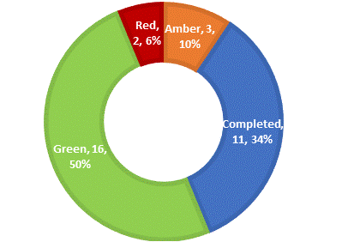
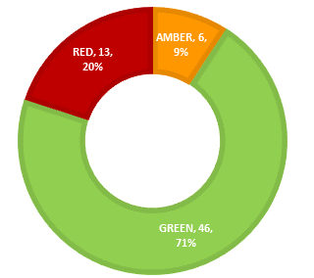

Performance by Priority: A council that puts residents first

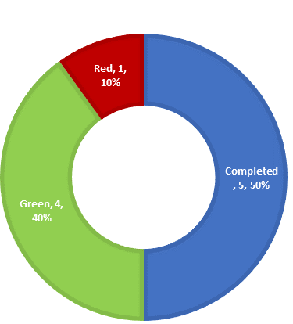
Flagship Actions Performance Indicators

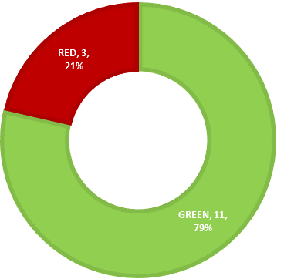

Key achievements in the quarter included:
- Successful implementation of the new planning system with an enhanced customer portal
- Resurfacing of footways and highways, and a week of action in Rayners Lane, installation of CCTV and delivery of Family Hubs
- Remembrance events at the Civic Centre and St John’s in Stanmore
- The annual canvas by Electoral Services has improved the accuracy of the electoral register, promoted registration and responded to Elections Act changes

Areas for improvement included:
- Installation of full fibre internet to all Council homes, which has been delayed due to financial issues in the industry
- Improving waiting times before telephone calls are answered
- Responding to Freedom of Information requests within 20 days

Performance by Priority: A borough that is clean and safe

Flagship Actions Performance Indicators
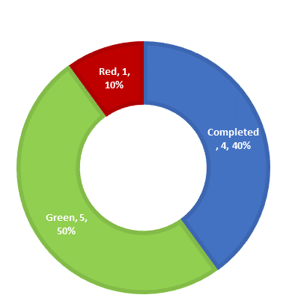

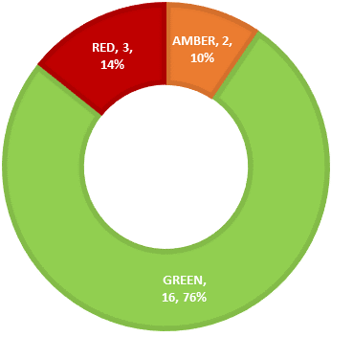

Key achievements in the quarter included:
- Reduction in catalytic converter theft, due to targeted operations with the police and other local organisations
- Safer Spaces website – resulted in 100 responses and 1400 views and is helping to make Harrow safer for women and girls
- Improved recycling rates, reduced residual waste
- Grange Farm Phase One was completed – delivering 89 new homes
- Improvements in building safety compliance and turnaround times for council houses
- Higher rates of homelessness prevention, in top 5 for London
- Lower high street vacancies, and improved public areas in the town centre
- Events at the Harrow Arts centre, including cultural heritage evens and the annual pantomime, which sold 13,600 tickets, the highest number ever
- BALI Award in Nature, Conservation and Biodiversity Enhancements for Headstone Manor Museum
- Exceeded targets in finding employment for local residents – with the best performance in London

Areas for improvement included:
- Grange Farm Phases 2 and 3 – delayed and under review, likely to start later in 2024
- Increased number of anti-social behaviour incidents
- Highway defects rectified within timescale
- Footfall in the town centre
- Electrical safety checks in council houses

Performance by Priority: A place where those in need are supported

Flagship Actions Performance Indicators
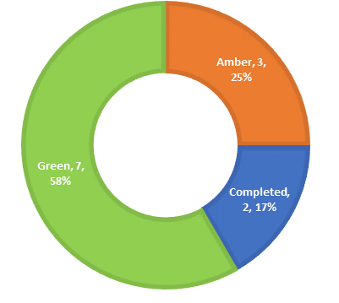
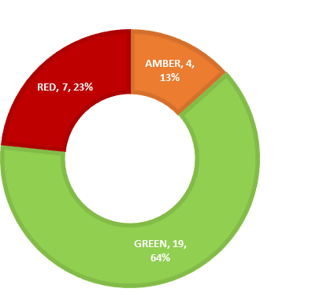

Key achievements in the quarter included:
- Provision of 25 warm hubs, providing health advice, exercise classes and a hot meal
- Providing opportunities for residents to be connected to others via the ‘Feeling Connected over Winter’ campaign
- Delivery of Fit4Life charters to 40 primary schools – to improve the health of Harrow’s pupils
- Launch of the hospital discharge bridging service
- Free school meals delivered to over 6000 children in each of the October half term and Christmas holidays
- 1500 vouchers and over 9000 food packages distributed to residents via Help Harrow
- Corporate support for 2 further years of Conversation Café - with extended offer including Citizens Advice for carers, disabled and vulnerable residents

Areas for improvement included:
- Improvements at some of Harrow’s Neighbourhood Resource Centres
- Children’s social care assessment timeliness
- Absence rates in local schools
- Exclusions from local schools
- Timeliness of Education, Health & Care Plans for Children with SEND

More detail on Q3 performance and Flagship Actions can be found in the appendices, along with a key to RAG (Red-Amber-Green) ratings.

Ward Councillors’ comments
Not applicable

Performance Issues

The report deals in detail with performance issues.

Data Protection Implications

Personal data is protected when reporting performance through aggregation of data, anonymisation and suppression of low numbers that might enable individuals to be identified.

Risk Management Implications
The risks arising from the Performance Report will be measured through the
Council’s Corporate and Directorate level Risk Registers.

Risks included on corporate or directorate risk registers?
Yes

Separate risk register in place? No

The relevant risks contained in the register are attached/summarized below.
N/A

The following key risks should be taken into account when agreeing the recommendations in this report:

Risk Description | Mitigations | RAG Status
Corporate performance information is not reported in a timely manner and this may prevent remedial action being taken promptly (where appropriate) in key areas | - Performance scorecards exist at service and Directorate level which include all the indicators in the Corporate Scorecard  - Managers receive real time data in critical areas e,g, outstanding assessments  - Service and Directorate level scorecards are considered in performance sessions with managers that occur soon after the period end – when the data becomes available, usually monthly.  - Information is available quickly and action is taken to address performance issues as they arise. | Green

Procurement Implications
None

Legal Implications
The Council has a duty under s.3 of the Local Government Act 1999 to make arrangements to secure continuous improvement in the way in which its functions are exercised, having regard to a combination of economy, efficiency and effectiveness. Draft guidance on compliance with this duty was published for consultation over the Summer of 2023. Whilst still in draft, the contents set out the Government’s expectations in terms of compliance.

The draft guidance refers to the role of the Office of Local Government whose objective is to increase transparency of performance in the local government sector. The guidance contains details on the characteristics of a well-functioning authority, which includes frequent monitoring, performance reporting and updating of the corporate and improvement plans, ensuring that plans are evidence based, current, realistic and enable performance to be measured, there should be alignment with the financial strategy, actual outcomes should be measured effectively and frequently interrogated, performance should be regularly reported to the public to ensure citizens are informed of the quality of services being delivered and there should be opportunities for resident and partner engagement in developing, monitoring and managing performance.

Financial Implications
There are no financial implications arising from this report.

Equalities implications / Public Sector Equality Duty
S.149 of the Equality Act 2010 requires public bodies to have due regard to the need to eliminate discrimination, harassment, victimisation, and any other conduct that is prohibited, advance equality of opportunity and foster good relations between persons who share a protected characteristic and those who do not. This requires the Council to collect, monitor and manage equality data and consider the impact of its decisions on different parts of the community. The Council should consider its equality duties in all aspects of its decision-making and has specific duties to publish equality objectives and information to demonstrate compliance with the s.149 duty.

Council Priorities

The performance report is arranged according to the 3 council priorities:

- A council that puts residents first

- A borough that is clean and safe

- A place where those in need are supported.

Section 3 - Statutory Officer Clearance
Statutory Officer: Sharon Daniels
Signed off by the Chief Financial Officer
Date: 22 February 2024

Statutory Officer: Sarah Wilson
Signed on behalf of the Monitoring Officer
Date: 22 February 2024

Chief Officer: Alex Dewsnap
Signed by the Managing Director
Date: 22 February 2024

Head of Procurement: Nimesh Mehta
Signed by the Head of Procurement
Date: 22 February 2024

Head of Internal Audit: Neale Burns
Signed on behalf of/by the Head of Internal Audit

Date: 22nd February 2024

Has the Portfolio Holder(s) been consulted? Yes ☒

Mandatory Checks

Ward Councillors notified: No, as it impacts on all Wards

EqIA carried out: No

Not required for the quarterly performance report

Section 4 - Contact Details and Background Papers
Contact: David Harrington david.harrington@harrow.gov.uk 07714 089170
Background Papers:
None
Call-in waived by the Chair of Overview and Scrutiny Committee: NO

British Association of Landscape Industries
Special Educational Needs and Disabilities

